PABSON, SHIVARAJ
1st Terminal Examination 2081
Class: 4 Time: 2Hours. Full Marks: 50
Time: 2 hrs Subject: Math (Set A)

Answer the following question:
1.a) A protractor has marked from 0$°$ to ......... 2
b) Draw a line segment PQ of length 5.6cm 2
c) Draw an angle of 120$°$. 2
2. Observe the given shape and answer the following
question. 5
a) What is the name of the given shape ?
b) Measure all the sides of the given shape?
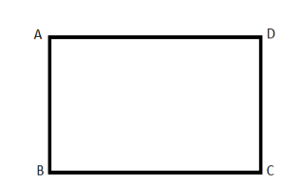
c) Which sides are equal to each other?

3 Show the numbers 98753 in the place value table and
Abacus. 5
4. The population of a town is 8347256 .
a) Write the number using comma (,) 1
b) Show the numeral in place value table . 2
c) Write the numeral in words. 2
5. Observe the following numeral 45,671
a) What is the place value of 5 . 1
b) Write the given numerals in Expanded form. 2
c) Write the numeral in word in Devnagari . 2
6. a) Write next five number starting from 48,02,790 1
b) Write in words : 27,11,270 1
c) Write the greatest and smallest number of 2,
0,8,0,9,7,5,1 3

7. a) Round off nearest Ten (10) . 3

34 | 174 | 8126

b) Round off nearest Hundred (100) 2
552 | 9849

8.a) Add the following 3 8 0 0 2 2
4 0 9 7 6
+ 7 6 9 5

b) My sister bought a second hand scooter for Rs 62875 and a
mountain bicycle for Rs 19426 . How much did she spend
altogether . 3
9 a) Subtract : 8 0 9 0 0 2
-1 2 0 5 7
b) Find the difference between greatest number of 6 digits
and greatest number of 5 digits . 3
10. The monthly incomes of a husband and his wife are Rs
53,025 and Rs.60000 respectively . If they spend Rs .35,025
altogether , find their saving for the month. 5
The End

